Project Report

Auto Irrigation System

Year: TY

Branch: ETRX

Batch: A4

Group: 6

Milan Dave ( 1412013)

Arat Gouda ( 1412028)

Kevin Zatakia (1412060)

**ACKNOWLEDGEMENT**

We have taken efforts in this project. However, it would not have been possible without kind support and help of many individuals and the college. We would like to extend our sincere thanks to all of them.

We are highly indebted to KJ SOMAIYA COLLEGE OF ENGINEERING for their guidance and constant supervision as well as for providing necessary information regarding the project and also for their support in completing the project.

We would like to express our gratitude for their kind cooperation and encouragement which helped us in completion of this project.

We would like to express our special gratitude and thanks to the faculty of the Electronics Department for giving me such attention and time.

We would like to thank Prof. Nirmal Jaganathan , HOD of ETRX department and Prof Sonia Joshi, our project guide for giving us this opportunity.

Table Of Contents:

Abstract……………………………………………………………...4

Flowchart…………………………………………………………...5

Block Diagram……………………………………………………..6

Circuit Diagram………………………………………..…………...7

All about Soil Moisture Sensor………………………………..…...8

Soil Moisture Calculations…………………………………….…...9

Components……………………………………………………….10

Methodology……………………………………………………....14

Circuit on Breadboard……………………………………..……...17

Expected Results…………………………………………….…....18

Project Justification……………………………………………….19

Project Scope…….……………………………………………….20

Conclusion………………………………………………...……...21

References………………………………………………………..22

**ABSTRACT**

This project on "Automatic Irrigation System on Sensing Soil Moisture Content" is intended to create an automated irrigation mechanism which turns the pumping motor ON and OFF on detecting the moisture content of the earth. In the domain of farming, utilization of appropriate means of irrigation is significant. The benefit of employing these techniques is to decrease human interference and still make certain appropriate irrigation. This automated irrigation project brings into play a microcontroller AT89S52 , which is programmed to collect the input signal of changeable moisture circumstances of the earth via moisture detecting sensors.

Key Words: Microcontroller, Irrigation, Soil Moisture Sensor, Automated Irrigation Mechanism.

**FLOWCHART**

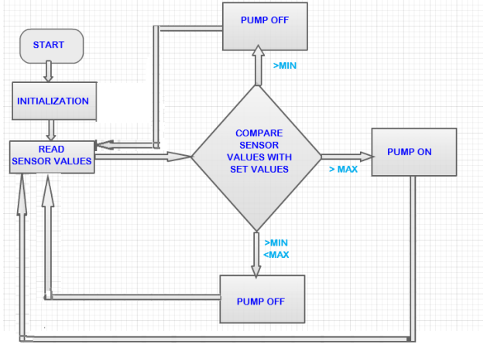

**Block Diagram**

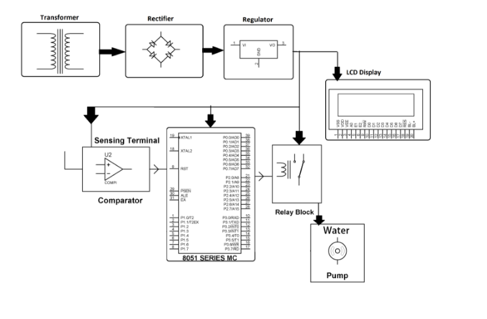

**Circuit Diagram**

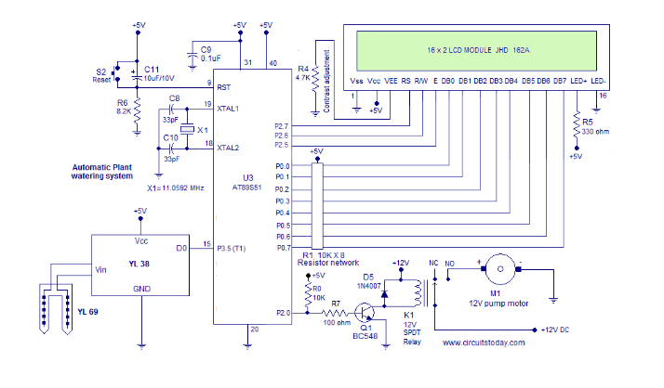

**All about Soil Moisture Sensors**

A sensor is a device that detects and measures a physical quantity from the environment and converts it into an electronic signal. The physical quantity could be moisture, temperature, motion, light or any other physical phenomenon. Examples of sensors include: oxygen sensors, temperature sensors, infrared sensors, humidity sensors, soil moisture sensors and motion detection sensors. The output of the sensors is usually charge, current or voltage. Of interest in this paper is the soil moisture sensor. A soil moisture sensor is a device that measures the volumetric water content (VWC) of soil. Mathematically VWC, θ, is given as follows;

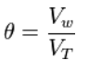

Mathematical representation of VWC

Where: Vw is the water volume and Vt is the total volume (soil volume + water volume). Soil moisture sensors are classified according to how they measure the soil moisture content.

**Soil Moisture Calculation:**

Two methods are used in determining the volumetric water content (VWC); direct and indirect. The direct method entails drying a known volume of soil in an oven and weighing it. The direct method of measuring VWC is done using the following mathematical notation:

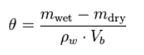

Where:

● Mwet is soil sample before drying in the oven

● Mdry is soil sample after drying in the oven

● ρw is water density

● Vb is the volume of soil sample before drying

Indirect method is based on correlating soil physical and chemical properties with water content. Three techniques are used in this method namely: chemical titrations, geophysical sensing and satellite remote sensing.

Chemical titration determines the moisture loss in sample soil after freeze drying or heating. Satellite remote sensing uses microwave radiation to check on the difference in dielectric properties of dry and wet soils. Geophysical sensing uses physical devices which are inserted in the soil to determine the soil moisture content. Techniques used in this method include: electrical resistance, electrical conductivity, soil dielectric, soil tension, TDR, FDR, soil capacitance among others.

**Components:**

1. 8051 Series Microcontroller ( AT 89S52 )

The AT89S52 is a low-power, high-performance CMOS 8-bit microcontroller with 8K bytes of in-system programmable Flash memory. The AT89S52 provides the following standard features: 8K bytes of Flash, 256 bytes of RAM, 32 I/O lines, Watchdog timer, two data pointers, three 16-bit timer/counters, a six-vector two-level interrupt architecture, a full duplex serial port, on-chip oscillator, and clock circuitry.

Data Sheet attached at the last

2. YL-69 Soil Moisture Testing

This is an Electrical resistance Sensor. The sensor is made up of two electrodes. This soil moisture sensor reads the moisture content around it. A current is passed across the electrodes through the soil and the resistance to the current in the soil determines the soil moisture. If the soil has more water resistance will be low and thus more current will pass through. On the other hand when the soil moisture is low the sensor module outputs a high level of resistance. This sensor has both digital and analogue outputs. Digital output is simple to use but is not as accurate as the analogue output.

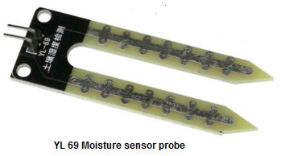

3. YL-38 Comparator Module

YL 38 comparator module is used in this project. It is a single channel Op-amp comparator based on L393 IC. This module just compares the output voltage of the sensing probe with a reference voltage and

Switches its voltage appropriately for the microcontroller to read. Circuit diagram of the YL 38 comparator module is shown below.

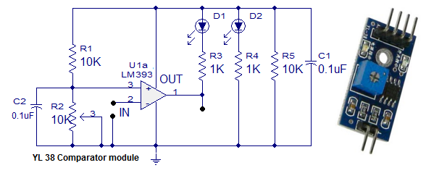

4. BC 548 Transistor

BC548 is general purpose silicon, NPN, bipolar junction transistor. It is used for amplification and switching purposes. The current gain may vary between 110 and 800. The maximum DC current gain is 800.

6. 12V Spot Relay   
This is an electromagnetic switch which is activated when a current is applied to it. A relay uses small currents to switch huge currents. Most relays use principle of electromagnetism to operate but still other operating principles like solid state are also used. A contactor is a type of relay which can handle a high power required to control an electric motor or other loads directly. Solid state relays have no moving parts and they use semiconductor devices to perform switching.

4. LCD Module

Liquid Crystal Display (LCD) screen is an electronic display module. An LCD has a wide range of applications in electronics. The most basic and commonly used LCD in circuits is the 16x2 display. LCDs are commonly preferred in display because they are cheap, easy to programme and can display a wide range of characters and animations. A 16x2 LCD have two display lines each capable of displaying 16 characters. This LCD has Command and Data registers. The command register stores command instructions given to the LCD while the Data register stores the data to be displayed by the LCD.

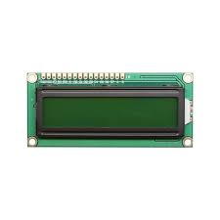

8. Crystal Oscillator ( 11.0592 Mhz)

11.0592 MHz Crystal Oscillator provides clock pulses of 11.0592 MHz frequency, a commonly used clock for 8051 based AVR microcontrollers. It is also suitable for use as UART clock as this frequency provides integer division to several popular UART baud rates.

9. Resistors - 100Ω, 8.2KΩ, 330Ω, 4.7KΩ

A resistor is a component that resists the flow of current. It’s one of the most basic components used in electronic circuits.

10. Capacitors: 33pF, 10uF, 0.1uf

A capacitor or electric condenser is a device that can temporarily store an electric charge.

11. 12V Pump Motor

High pressure miniature diaphragm pump water pump price

Voltage:DC12V/24V DC6V

Flow:620ML/min,>3bar

Working voice:less than 50dB

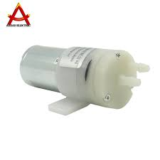

**METHODOLOGY**

The automatic irrigation system was designed to continuously sense the moisture level of the soil. The system responds appropriately by watering the soil with the exact required amount of water and then shuts down the water supply when the required level of soil moisture is achieved. The reference level of soil moisture content was made to be adjustable for the three most common soil samples (sandy, loamy and clayey soils.) The moisture sensors were designed using probes made from corrosion-resistant material which can be stuck into soil sample. Voltage levels corresponding to the wet and dry states of the soil sample were computed by measuring the resistance between the moisture detector probes and matching them to output voltages of a comparator circuit. A submersible low-noise micro water pump was developed to deliver the water to the appropriate parts of the soil (the base of the plants). The volume of water required for irrigation per time was computed by considering the capacity of the water pump and the water channels. The required irrigation time was determined by considering the response time of the water pump and the water volume required per irrigation instance. A timing circuit was designed to use the required irrigation time to control the duration of each irrigation instance. Simulations were done using Development kit circuit simulation software. Circuit construction was done on a Vero board.

**WORKING:**

Objective of the Auto irrigation system is to provide the user the complete automation of the system so what the project does is that it uses YL-69 as the soil moisture sensor which is the main component which reads the moisture in the soil once the data read is sent to comparator YL- 38 to compare the values obtained so it either returns high or low as digital read from pin Do the micro controller accepts the digital read data from the pin number Port 3.2 of At89s52which is 8051 Atmel microcontroller the data read from the pin is processed by the algorithm designed so also at the side of the LCD “Auto irrigation system” is displayed at the start of the device when powered on

The output voltage of the sensing probe is connected to the inverting input of the opamp. When the moisture level is high more current passes through the sensing probe and so the voltage at the inverting pin will be higher than the reference. The reference can be set using the trim pot R2. At this condition output of the opamp goes low and sinks the LED D1 to make it glow.

Case 1 : When the moisture is lower than the set point, the opposite happens. So in simple words, a LOW output of the opamp indicates a high moisture which gets displayed at the LCD Screen, the spot relay disconnects the connection and the pump motor stops.

Case 2: HIGH output of the opamp indicates a low moisture which is displayed on the LCD screen and thus then after verifying the situation the relay makes a connection and thus motor pump runs (relay interfaced at pin 3.1)

The output of the opamp is marked as pin D0 on the sensor YL 38 module.

LED D2 is just a power ON indicator. Capacitors C1 and C2 are noise filters

LCD is interfaced at port 2 of microcontroller and RS is at P1.0;

RW is at P1.1; EN=P1.2.

**Circuit on Breadboard**

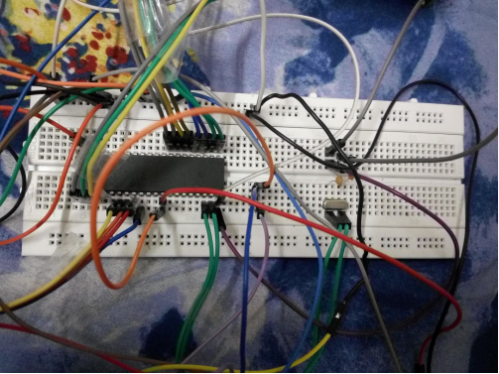

**Expected Results**

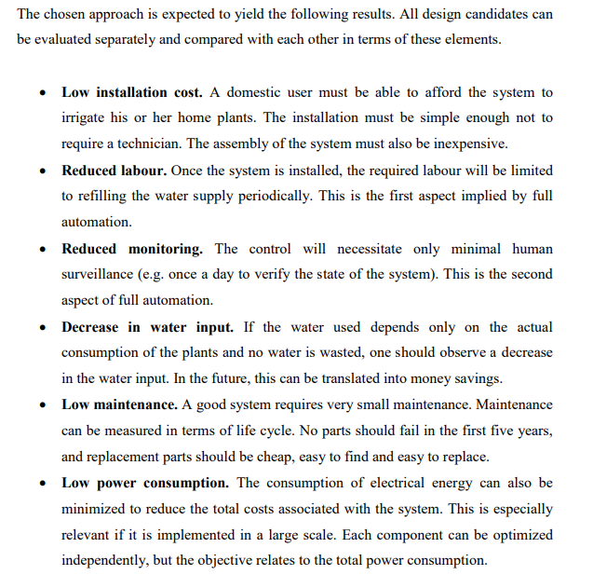

**Project justification**

The increasing world population has lead to exponential increase in food demand. This event has necessitated the need for more land to be cultivated. Due to change of weather patterns brought about by global warming, irrigation remains as the only reliable method of crops production. With more and more land now being under irrigation there is a need for optimal use of water.[2] Over the last few years knowledge in electronics and computation has been used to solve present day challenges. In the forefront of the electronics revolution has been the microcontroller. The microcontroller has been used together with various sensors to measure and control physical quantities like temperature, humidity, heat and light. By controlling this physical quantities using the microcontroller; automatic systems have been achieved. Irrigation systems in crop production can and has also been automated. This solves the challenge brought about by the unreliability of climate changes thus need for water optimization. Automation of the irrigation systems is one of the most convenient, efficient and effective method of water optimization. The systems helps in saving water and thus more land can be brought under irrigation. Crops grown under controlled conditions tend to be healthier and thus give more yields. Controlled watering system results in reduction of fertilizer use and thus fertilizer costs go down .

**Project Scope**

The scope of this project entails the design and implementation of a micro controlled irrigation system, depending on the soil moisture content. Humidity/moisture sensor will be the input of the system and an electric water pump will be the output of the microcontroller.

**Future Enhancements**

1. A wireless sensor and GPRS(General Packet Radio Service) based automated irrigation system can also be employed, which will help monitor the soil moisture and to control the application of water to the agricultural products thereby saving water.

2.Integration of faster processors and GSM 900A can be used to drive the motor remotely from hand via text messages and also create internet hotspot for further IoT applications

3.Integration of Node MCU8266 to develop a remote server of storing and keeping track of data

4.Do data prediction and make it more feasible and automated system

**Conclusion:**

Automatic irrigation control system has been designed and constructed. The prototype of the system worked according to specification and quite satisfactorily. The system components are readily available, relatively affordable and they operate quite reliably. The system helps to eliminate the stress of manual irrigation and irrigation control while at the same time conserving the available water supply. Improving Irrigation efficiency can contribute greatly to reducing production costs of agricultural products, thereby making the industry to be more competitive and sustainable. The system was tested on three types of soil and from the result analysis sandy soils require less water than loamy soils and clay soils require the most water for irrigation. For future work on this project, we recommend that for a large scale implementation a more powerful water pump can be used. Also a microcontroller should be used to accommodate more than one sensor input and also control different irrigation regimes independently. A wireless sensor and GPRS(General Packet Radio Service) based automated irrigation system can also be employed, which will help monitor the soil moisture and to control the application of water to the agricultural products thereby saving water.

**References:**

[1] Massimo Banzi, Getting started with Arduino, Second Edition, O’Reilly Media, Inc, 2011

[2] Francis Z. Karina and Alex Wambua Mwaniki, irrigation agriculture in Kenya, Nairobi, Kenya, 2011

[3] Allan Trevennor, Practical AVR Microcontrollers, New York , USA, Springer Science + Business Media, 2012

[4] Clemmens, A.J. Feedback Control for Surface Irrigation Management, ASAE Publication 04 -90, 1990.

[5] Songle relay Datasheet

[6] Soil moisture sensor datasheet

[7] W. C. Dunn, Introduction to Instrumentation Sensors, and Process Control, British Library Cataloguing, 2005

[8] General Purpose Transistors NPN Silicon (KSP2222A) datasheet